William Pete Bingham

CS-499

Southern New Hampshire University

3/1/2020

Milestone Four: Narrative

**A.**

The Artifact that I had chosen for milestone three is from CS-360: Mobile Application and programming. This artifact was created in August of 2019. The purpose of this application is to allow a user to search for parks nearby on google maps with google maps API and Bing search API included. The user would sign onto the application and immediately be able to use the application without a sign in phase.

**B.**

The purpose of this artifact being chosen for my ePortfolio is because we needed to self-improve on databases for this artifact. I chose to create a database that would store user information such as username and user password. Once the user registers with the application, they are prompted to type in a username and password and then sign in with there newly registered credentials. If the user has already created a username and password, the user can just simply sign in. Displayed below will be images of the application in use from start to finish. The user may use this code inside of android studio as well, if they would like to test out the application. Please keep in mind though that my code does have my google API key.

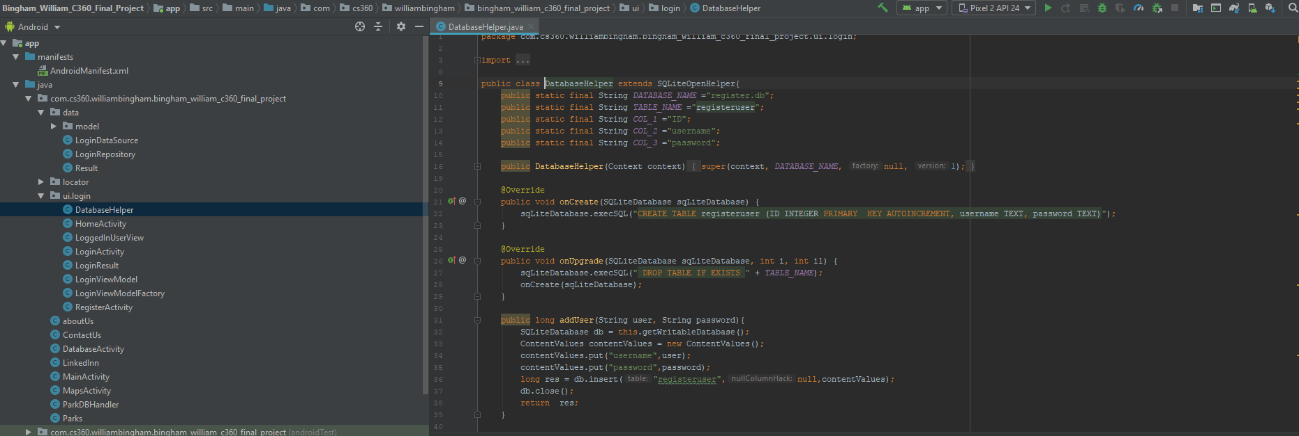

This is the database displayed above, for my username and password.

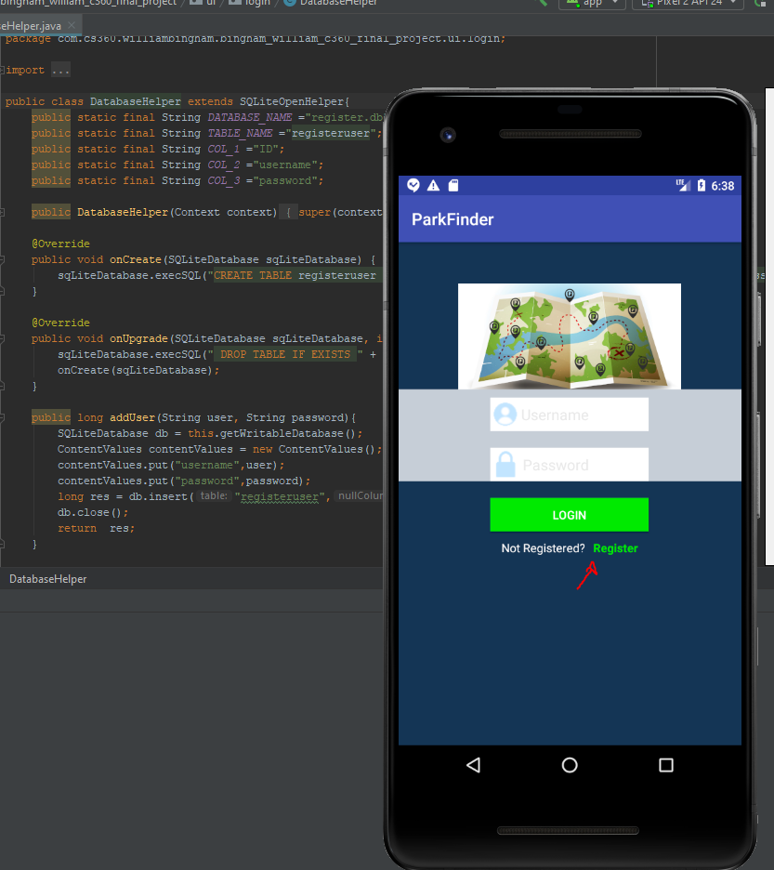

Displayed above is the login screen when the user starts the application. The user can select “Register” to begin the process.

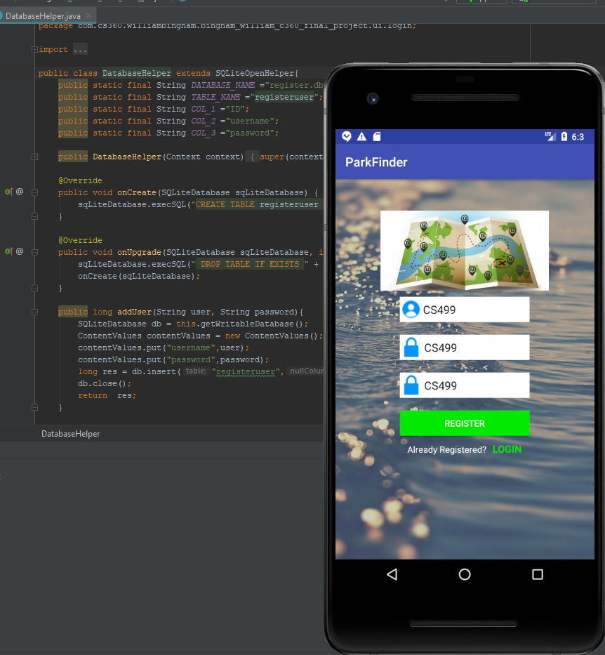

The user can type in his or her username and password and confirmation password and then click Register to complete.

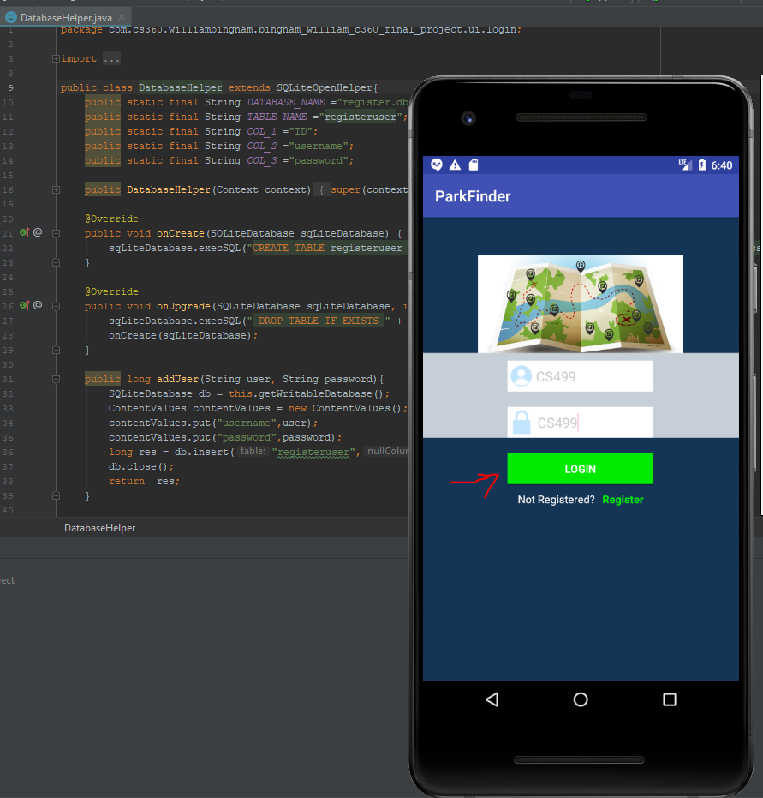

When the user is back to the home login screen, they can then input their credentials to sign in. If the user does not use the correct credentials, then the user will be denied access to the application.

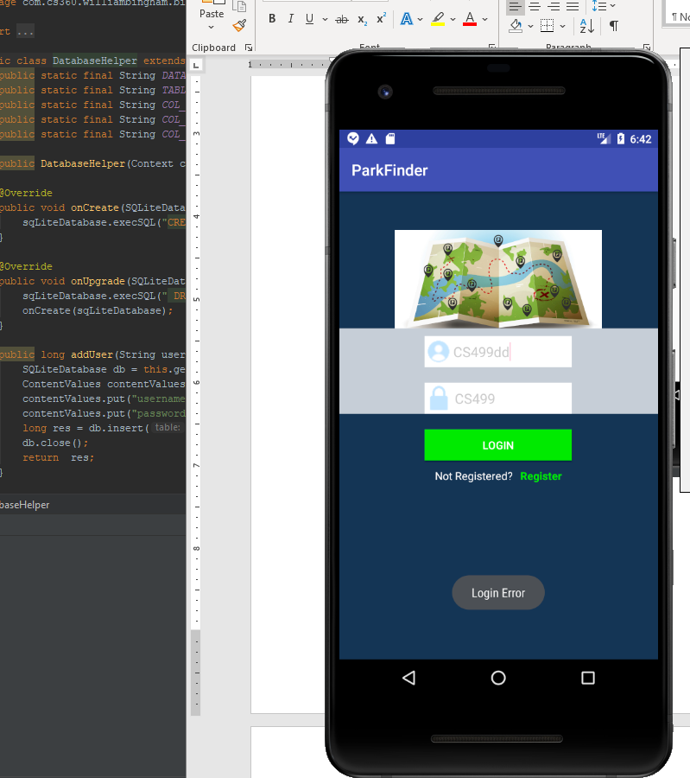

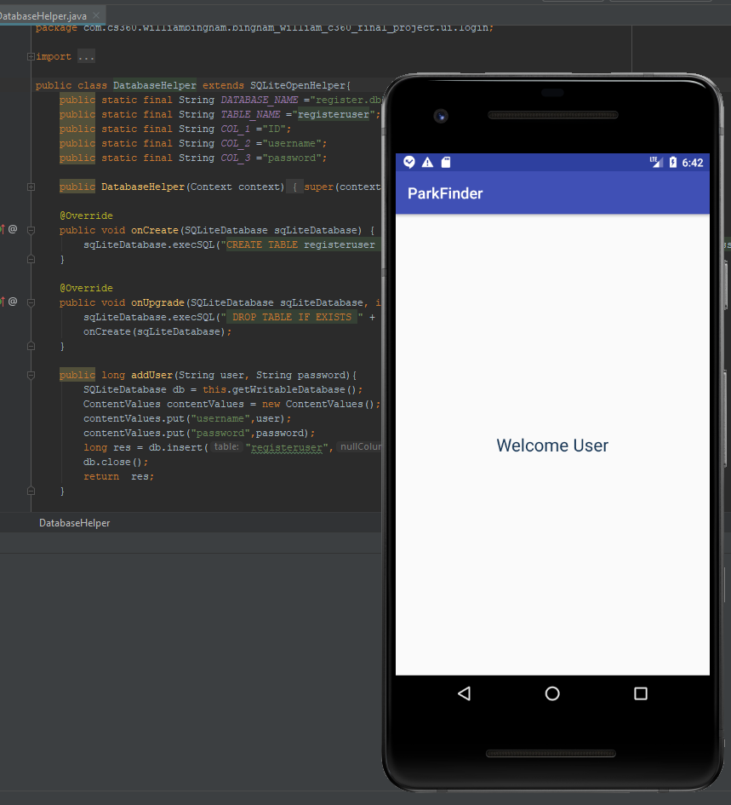

The image above shows the welcome user sign in page, whenever the user properly signs in and is granted full access to the application.

I believe that my skills in programming algorithms, and databases have been proven here in this artifact. Not only was I able to successfully implement as working user database, I created a secure application that made the user provide its proper credentials. This shows skill in secure programming.

**C.**

I believe that I did meet the course requirements and outcome of this project. Overall, I was able to complete the requirements that I had given myself for this project. I was able to display my skills properly and made my application safer to use.

**D.**

Some of the things that I learned from this project was how to properly code a working database that would store user information such as username and password and then allow that person to sign back in with that same username and password. This week was a nice task to complete, and I had to think outside of the box in terms of getting this database to work properly. Again, I think this is still my best work here at SNHU and I believe that it will be a great piece to show future employers, especially if they have a need for database development.